# SoE 2021 Marine Expert Assessments

# STATE AND TREND ASSESSMENT: Water quality (turbidity, physicochemical properties)

Martina A. Doblin1,2, Jason D. Everett3,4,5, Claire Davies6

1. Climate Change Cluster, University of Technology Sydney, NSW
2. Sydney Institute of Marine Science, NSW
3. School of Mathematics and Physics, The University of Queensland, QLD
4. CSIRO Oceans and Atmosphere, Queensland Biosciences Precinct, St Lucia, QLD, 4067, Australia
5. Centre for Marine Science and Innovation, School of Biological, Earth and Environmental Science, University of NSW, Sydney, NSW, 2052, Australia.
6. CSIRO Oceans and Atmosphere, Hobart, TAS

**Suggested reviewers:**

Dr Bozena Wojtasiewicz, CSIRO; Bozena.Wojtasiewicz@csiro.au

Prof David Antoine, Curtin University; David.Antoine@curtin.edu.au

Prof Peter Strutton, University of Tasmania; Peter.Strutton@utas.edu.au

Marine environments (continental shelf and open ocean) are influenced by regional variation in climate, geomorphology and oceanography, all of which regulate the concentration and nature of the dissolved and particulate materials in seawater. These constituents collectively determine water quality.

Australian marine waters are generally low in suspended sediments (turbidity) and colour (coloured dissolved organic matter) resulting in relatively deep light penetration that allows pelagic primary producers (phytoplankton) to persist in waters greater than 100 m. Marine ecosystems are adapted to these conditions and therefore any deterioration (i.e., increased turbidity or decreased optical transparency) in water quality threatens key habitat-forming benthic primary producers such as kelps and seagrasses.

In oceanic and outer continental shelf waters the major determinant of turbidity, transparency, and colour is the biomass of phytoplankton (Yentsch 1960), with phytoplankton growth largely being driven by the availability of dissolved nutrients. However, water transparency declines strongly toward shore due to increased sources of sediment, nutrients and greater phytoplankton biomass.

The northern waters of Australia (Timor and Arafura Seas) have highest suspended sediment (lowest transparency) relative to southern waters, and those in the Coral Sea have greatest transparency (Secchi disk depth; Fig. 1). Water transparency is strongly seasonal, generally reaching a minimum in spring and summer due to growth of phytoplankton (as indicated by peaks in chlorophyll-a (Chl-a) concentration; Fig. 1).

Tidal flows and waves contribute to turbidity, but extreme events such as tropical cyclones and storms can increase the level of suspended sediment by up to 3 orders of magnitude (x1000) due to both runoff and bottom disturbance by waves. In addition, tropical rivers in areas of high rainfall can deliver large amounts of sediment to the coastal zone, with plumes sometimes being quite extensive.

Current state: Australian marine waters largely contain relatively low levels of suspended particulate matter and moderately low concentrations of Chl-a. Water transparency, a function of both non-pigmented and pigmented particles as well as dissolved organic matter, is relatively high.

Trend: Water transparency (as indicated by Secchi depth estimated from satellite) is declining across subtropical and temperate Australia but remains stable in tropical waters in the north and the north-east (Coral Sea). In the south-east and south-west, decreasing transparency is linked to significant increases in Chl-a with no significant change in suspended matter (Figure 1).

Estimates derived from *in situ* water samples collected at the IMOS National Reference Station at Rottnest Island show similar trends to satellite-based regional estimates, providing an added level of confidence for these trends (Figure 2). Significant increases in Chl-a between 2003-2020 are evident for the majority of waters in the Great Australian Bight and subtropical eastern Indian Ocean (Figure 3).

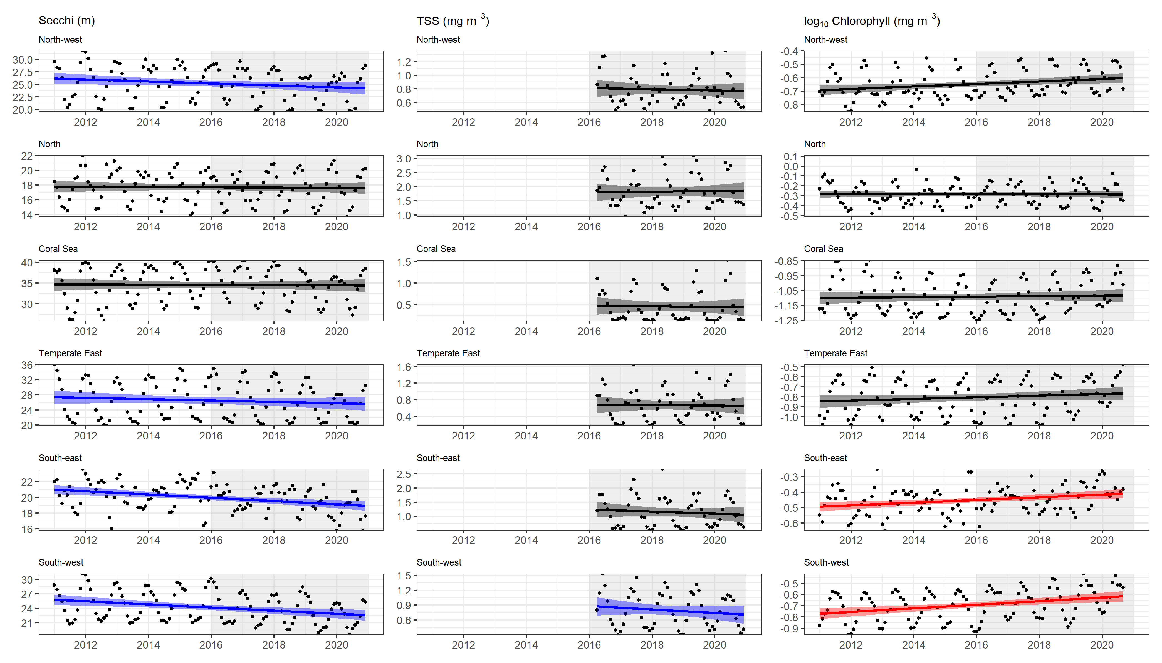

Figure 1. **Water quality status and trend in Australian marine waters.** Interannual variability and long-term trend in water quality parameters as estimated from satellites from different regions: north-west, north, Coral Sea, Temperate East, South-east and South-west Australia (see Figure 3 for regions). Secchi disk depth is an indicator of water clarity that is a function of dissolved and particulate material in the water column. Total Suspended Solids (TSS) comprise both pigmented and non-pigmented particles, and Chl-a concentration represents pigmented particles. Black line indicates no significant trend, blue line indicates significant negative trend, red line indicates significant positive trend.

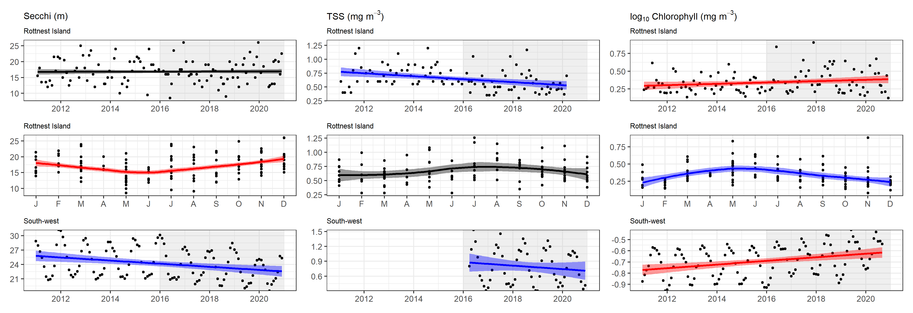

Figure 2. **Comparison of in situ versus satellite trends in water quality.** Top row: In-situ water quality data from the IMOS NRS at Rottnest Island, WA, showing no trend in water clarity (Secchi depth), declining TSS and increasing Chl-a from 2011-2020. Middle row: Seasonal and inter-annual variation of water quality at Rottnest Island NRS showing peak phytoplankton in late autumn-early winter. Bottom row: Satellite-derived Secchi depth, TSS and Chl-a data from the south-west region of Australia during 2011-2020.

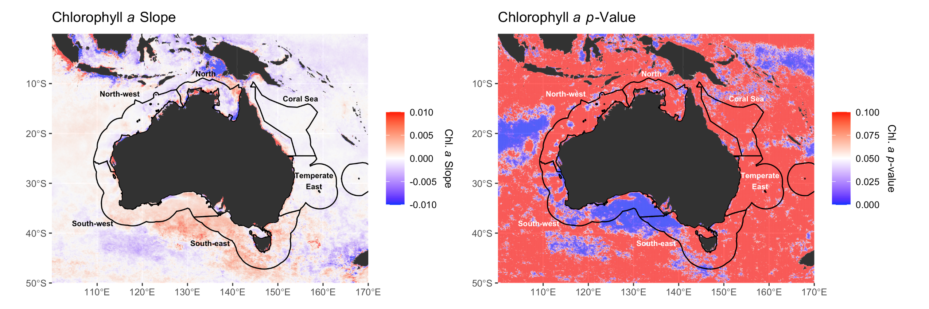

Figure 3. **Map of chlorophyll-a trend.** Spatial summary of significant trends in chlorophyll-a in marine waters around Australia.

**Assessment summary**

Water quality as defined by water transparency is relatively good and stable across most of Australia’s marine estate. However there is a decreasing trend of water transparency in the south-west and south-east, as well as the Great Australian Bight due to increasing Chl-a concentrations. In the longer term, climate change is expected to cause declining chlorophyll-a in northern Australia and increasing chlorophyll-a in southern Australia.

|  |  |  |  |  |  |
| --- | --- | --- | --- | --- | --- |
| Year | Assessment grade | | Confidence | | Comparability with previous assessment |
| Grade | Trend | Grade | Trend |
| 2021 | Good | Stable | Somewhat adequate | Adequate | Grade and trend are comparable to the 2016 assessment |
| 2016 | Good | Stable | Adequate high quality evidence and high level of consensus | Adequate high quality evidence and high level of consensus | Grade and trend are comparable to the 2011 assessment |
| 2011 | Very good | Stable | Limited evidence or limited consensus | Limited evidence or limited consensus |  |

Data confidence: Satellites provide high spatial and temporal coverage for surface waters, but have uncertainties related to limited regional tuning of global algorithms to convert remotely sensed signals to water quality estimates in the Australian region. The growing data record at the IMOS Reference Stations enables the comparison of in situ measures with satellite data, increasing the level of consensus.

# Metadata

1. Data used in the assessment, including spatial and temporal coverage

Water quality data was derived from two sources:  
i) IMOS National Reference Stations, sampled monthly  
ii) Globcolour, a time-series of ocean colour data merged from four satellite data sources: MERIS, MODIS, SeaWIFS. Globcolour data was accessed in a bounding box of 110-150 oE and -10:-45 oS over a time period that spanned the last 2 SOE periods, 2011 – 2020. The TSS product was only available from early 2016 onwards.

For more information: <https://www.globcolour.info/products_description.html>  
  
Satellite sensors have the appropriate spatial (m to km) and temporal coverage (min to days), to assess water quality but require algorithms to convert satellite remote sensing reflectance into biogeochemical properties. While global algorithms are biased towards validation data collected predominantly in the northern hemisphere, satellite data remain the longest time-series with which to assess the status of marine water quality. These data are complemented by in-situ time series at IMOS National Reference Stations in a limited number of locations around Australia.

1. Quality of data used in the assessment

i) In situ data is collected using nationally consistent protocols and details can be found at <https://s3-ap-southeast-2.amazonaws.com/content.aodn.org.au/Documents/IMOS/Facilities/national_mooring/IMOS_NRS_BGCManual_LATEST.pdf>.

ii) Satellite data has not been extensively validated for the Australian region, but in eastern Australia, the uncertainty in Chl-a has been estimated at ± 37 % (Laiolo et al. 2021).

1. Custodian and location of data

The data custodian for NRS data is IMOS and is available to the public via the AODN. <https://portal.aodn.org.au/search>

Globcolour is The European Service for Ocean Colour, GlobColour is an ESA Data User Element Project and products and related information are available through <https://www.globcolour.info/products_description.html>

1. Method used to determine state or recent trend

To assess the trend in water quality parameters we used linear modelling in the R statistical package. The parameter in question was the response variable with year and month as predictors.

1. If the assessment has changed from the 2016 assessment, what factors/parameters have contributed to the change and how?

There was a significant increase in Secchi disk depth from 2009-2015 in the Australian region (10°S to 45°S and 105°E to 160°E), indicating the water was becoming more transparent. The assessment from 2016-2021 indicates that this can mostly be attributed to a decrease in non-pigmented particles (total suspended solids), as Chl-a concentrations are increasing in some regions.

1. Links to relevant publications

Davies, C. and Sommerville, E. (Eds.) (2020), National Reference Stations Biogeochemical Operations Manual Version 3.3.1. Integrated Marine Observing System. DOI: 10.26198/5c4a56f2a8ae3 (<http://dx.doi.org/10.26198/5c4a56f2a8ae3>)

Laiolo, L., Matear, R., Soja-Wo´zniak, M., Suggett, D.S., Hughes, D.J., Baird, M.E., and Doblin, M.A. (2021) Modelling the impact of phytoplankton cell size and abundance on inherent optical properties (IOPs) and a remotely sensed chlorophyll-a product. J. Marine Systems 213: 103460. https://doi.org/10.1016/j.jmarsys.2020.103460